RAW on the run
The initial concept was simple. The old laptop I have is heavy, cumbersome and very slow and while travelling I would rather have the carry-on kilos for camera gear rather than for backup or processing. I cannot afford a new computer to store and process while on the run. The new Microsoft PowerBooks are about to come out but I reckon they are still too expensive for the grunt just as the current model is. I suspect Microsoft is looking at price points rather than lowering a price point.

Rant over; what is the Aim of the Game:
- Using an Android pad rather than a laptop to back up camera RAW files while on the road. My preferred approach is to have 2 separate portable hard disk drives (one for me and one for my wife) to spread the risk.
- If possible; use the tablet to do some minor edits while on the road.
Step1 Backing up to the tablet
Well I thought this would be easy…………………….
Gear: Samsung Galaxy S2 with a 128Gb micro SD card (like to see you do that on an iPad)
Canon 7D Mk1 camera which uses CF not SD cards and is not Wi-Fi.
Approach: Copy files from the CF card to the tablet’s micro SD card then copy from tablet to each HDD. For clarity I will refer to the memory on the micro SD as simply part of the tablet.
Step 1: Copying from CF to tablet.
Success!!! This was very straightforward. Acquire an On The Go (OTG) micro usb to female USB 2 cable. Plug in a standard card reader into the USB 2 of the OTC and then into the tablet. I used the native Samsung “My files” app to transfer from CD card to the tablet just as you would File Explorer or Directory Opus on a PC or Mac. See Figure 1
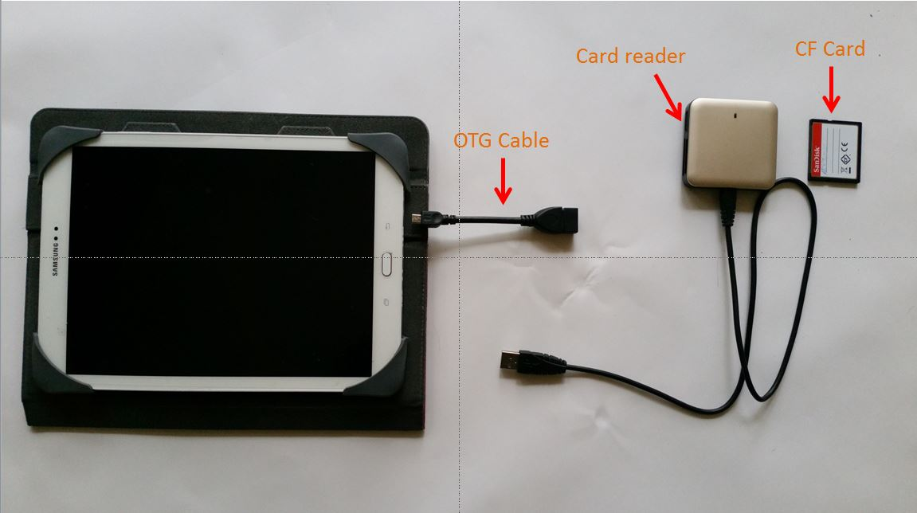
Figure 1 Set up for transfer from CF card to tablet
Later I found out about a Mini-USB-2-0-Micro-USB-OTG-Converter-Adapter-for-Samsung-for-HTC-Android-Mobile (Figure 2).
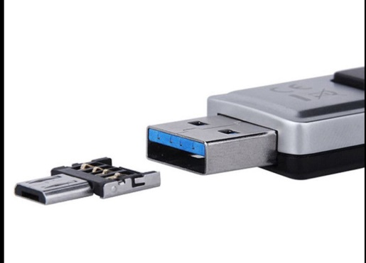
Figure 2: Mini-USB-2-0-Micro-USB-OTG-Converter-Adapter

They simply fit into the USB A end and become a micro usb2 replacing the need for an OTG cable. Cost, $1.99, including postage. I bought two. Be careful they are tiny but great
Here is where I got it:
http://www.ebay.com.au/itm/Mini-USB-2-0-Micro-USB-OTG-Converter-Adapter-for-Samsung-for-HTC-Android-Mobile/322415936032

Step 2 From tablet to HDD
Er, not so easy. This is where the adventure really begins. I have arrived at a solution that suits me through trial and error. Maybe I should rephrase that - I arrived at a solution through error and a lot of trials. As there is nothing clear on the internet about any of this I am writing this down so others do not have to go through the same pain or can find errors in my approach that will make things easier for me and others. I tackled this next stage looking at a number of options. Some I knew would fail at the start, but I have them here for completeness after testing them

Option 1 – The naïve and doomed to fail approach.
Plug a portable HDD into the USB end of the OTG cable.
This did not work. I use portable HDDs that rely on the USB connection for their power. Simply put, the tablet cannot supply the necessary power to the HDD.
I did not test any independently powered HDDs that plug into an AC socket. A) I don’t have one, and b) even if I did I think they might be a bit cumbersome for travelling.

Option # 2 Using a Lavalink OTG Host/Charge adaptor
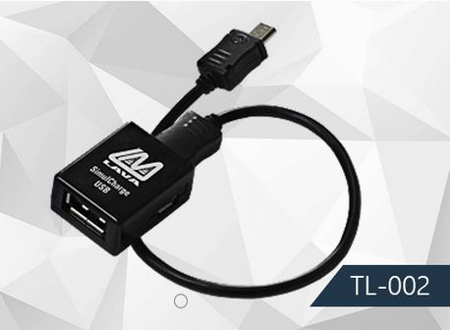
Figure 3: Lavalink TL-002
This works…………………….but there is a few big big BUTs!
Figure 3 shows the connector I used. It pays to visit Lavalink.com as there are variants for different applications. Essentially this is a 3 way adaptor, one connection to your tablet, one connection to the portable HDD using as USB 2 A type connection, and the third is a micro usb to the AC. You have to scratch around for a supplier willing to deliver to Australia. I used Fishpond there may well be others.
Figure 4 shows tablet, HDD and AC power connected to the Lavasoft.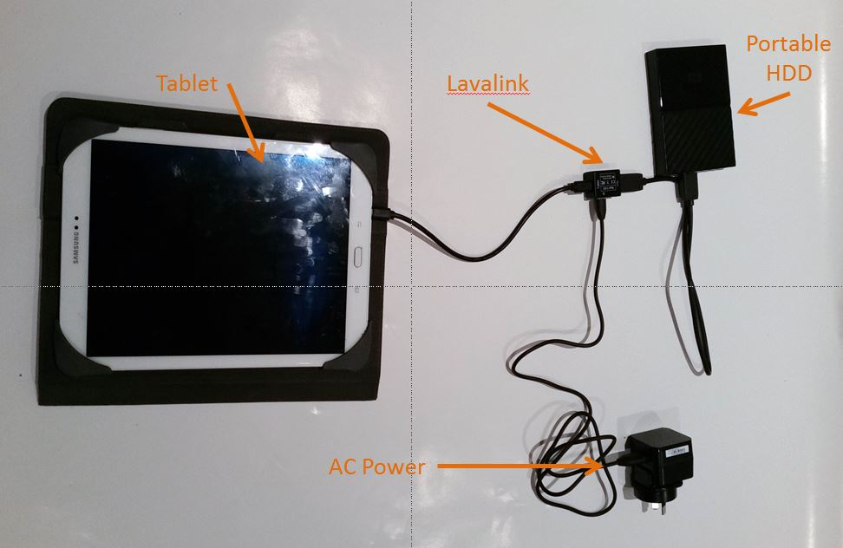
Figure 4: Tablet, LavaLink, Portable HDD and AC power supply for transfer to HDD from Tablet.
A quick digression as this is important for any of this to work. Disk formatting.
There are 3 types of formatting for disk drives. Going from oldest to newest in Windows they are FAT32, exFAT and NTFS. Computing devices formatted with newer formats can read earlier formats but not the other way around. Newer Macs use HTFS+
Most memory sticks and similar things use FAT32. This is the oldest and most compatible formatting and can be read by Macs and Windows based systems as well as android. The problem with FAT32 is that it has a file limit of 4Gb. exFAT overcomes this and is sometimes called FAT64. It is compatible with newer androids and Mac OS X 10.6.5 and later versions.
If you want to know more about this stuff, here is one reference: http://guides.macrumors.com/File_systems
Now most portable HDDs are preformatted NTFS, so you need to re-format it as one of the others Mac users know this. Windows 10 disk manager gives only a choice between NTFS and exFAT. I reformatted all my portables in exFAT. There are net resources to use FAT32 if need be.
Now on with the show…..
To cut a really tedious and long story short,
What worked with this set up: 1Tb WD my passport old style, 1Tb WD My Passport new style, (Note these are NOT My Passport Ultras).
What did not work: 1Tb Seagate Slim, 2Tb WD My elements
All of these HDDs are USB powered. I suspect that some need more power than others through the connection, for me only the 1Tb WD My Passports worked. I might be missing something but that is simply my experience.
Other learnings
First time connection: Be patient the tablet and HDD have to shake hands =, allow 3 or 4 minutes as the android adds a few folders onto the HDD. Subsequent connections take 1 minute only (this can seem a long time) transfer of RAW files is reasonable quick. The WD My Passports blink for a while then when the light goes steady the connection has been made. Worked like a charm.
Wall connector. I tried both a 2.4 amp and a 1amp, I used the 2.4 for the initial connection and both the 2.4 and the 1.0 thereafter. Did not seem to make a difference although at one point I thought the inability of the Elements and Slim to connect was due to lack of power from the AC. Higher amperage made no difference.
Option #3
Using a USB 4 Port OTG Hub.
Did not work on any HDD or power source.
It did supply power to the tabled and HDD simultaneously but no data transfer.

Option #4
Y Cable. A USB female with 2 wires, one a micro usb to power the other to the tablet.
Did not work.

Conclusions (so far)
The Lavalink device was the only one that worked with any reliability
The WD My Passport 1Tb drives were the only ones that enabled data transfer.
The native Samsung “My Files” App was up to the job and transfer was reasonably quick.
Other alternatives:
A portable HDD directly powered by AC, this theoretically should work but they tend to be heavy bricks that sort of defeats the purpose when travelling.
WD My passport wireless. Sets up a Wi-Fi between the tablet and the HDD. HDD has own battery and can be also be used to charge the tablet. Comes with a WD App – “My Cloud” that makes it all happen. Costs about $350 for a 1Tb drive.
Gnarbox: Just been released, looks like a HDD with multiple connections and Wi-Fi, a bit like the My Passport wireless on steroids. I haven’t seen one but it looks like being another viable solution. Cost?

Disclaimer: This is a record of my own experience and should not be construed as a recommendation for one solution over another. There may well be issues I have not accounted for. This paper is designed to help others in their own path of discovering a solution for themselves. All constructive comments/experiences welcome.
marlandd@aanet.com.au

